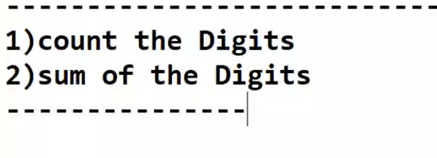

num=int(input("Enter the number:"))  
count=0  
temp=num  
  
while(temp!=0):  
 count=count+1  
 temp=temp//10  
 #print("temp:", temp)  
  
print("Count of digits:",count)

Enter the number:123456

Count of digits: 6

num=int(input("Enter the number:"))  
sum=0  
temp=num  
  
while(temp!=0):  
 digit=temp%10  
 sum=sum+digit  
 #print("sum:",sum)  
 temp=temp//10  
 #print("temp:", temp)  
  
  
  
print("Sum of digits:",sum)

Enter the number:123456

Sum of digits: 21